**Front page**

# *Entrepreneurship*

The Center for Entrepreneurship is focused on developing the skills and traits of successful entrepreneurs that can be used by students from any major to find solutions to market needs or social issues.

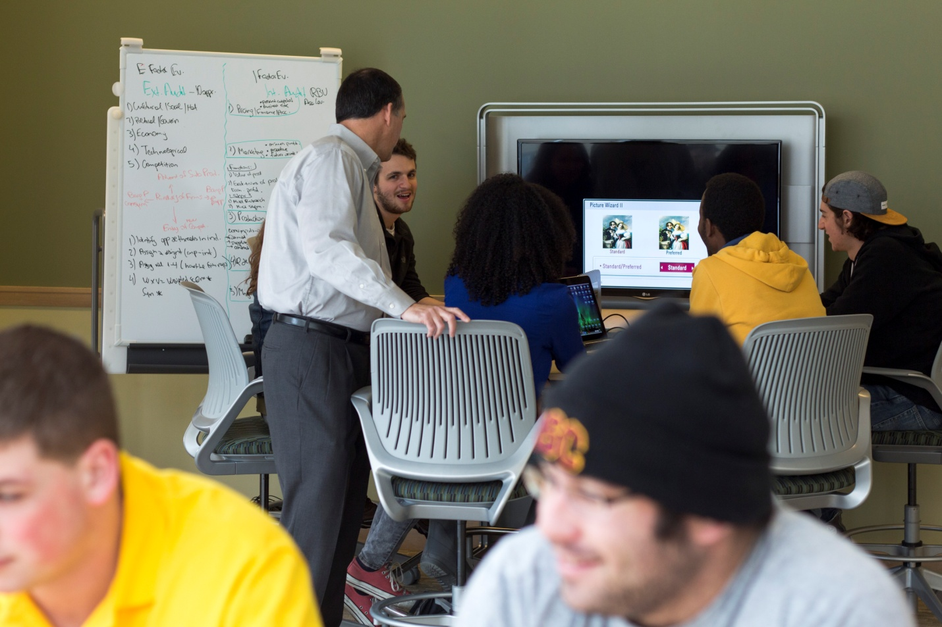

## Mission of the Center

The Center for Entrepreneurship helps students across all majors acquire the knowledge, skills and tools necessary to develop entrepreneurial traits they can apply to their professional careers, graduate school, volunteer pursuits or their own ventures. The pedagogical focus is the integration of the knowledge and skills derived from a liberal arts education with the practice of entrepreneurship to empower students to take ownership of solutions that create economic and social value.

**Side Navigation**

**About**

The Center for Entrepreneurship gathers useful information on entrepreneurship and connects students into a network of experts who can help in all phases of entrepreneurial development.

**Partners and resources**

The Morgan foundation

<http://www.bdmorganfdn.org/>

**Academics**

Students can take the interdisciplinary Introduction to Entrepreneurship course to learn how companies are started and what impact entrepreneurship has on society.  Other courses on campus help students develop the skills necessary to think and act like an entrepreneur.

**Introduction to entrepreneurship**

Introduction to entrepreneurship will introduce students to the multidisciplinary world of entrepreneurship. The course will survey and explore the fundamental components of entrepreneurship and its connectedness to a liberal arts education. The course will take students through various entrpreneurial phases including prelaunch, launch, growth and maturity of an entrepreneurial endeavor. Students will be introduced to the basic elements of entrepreneurship and highlight both entrepreneurial success and failure. Students will be challenged to think differently by being innovative, creative and forward thinking.

**New course (show course description)**

**Faculty**



Dr. Peter Abramo, Director of Entrepreneurship

**Start Your Own Company**

A number of Wooster students have started their own companies.  The Center can guide you through the development of your idea and the process for setting up a new company in Ohio.

**Fahim Aziz:**[**Backpack**](http://launch.spaces.wooster.edu/fahim-aziz-backpack/)



**Tarik Welch:**[**Juice**](http://launch.spaces.wooster.edu/tarik-welch-juice/)

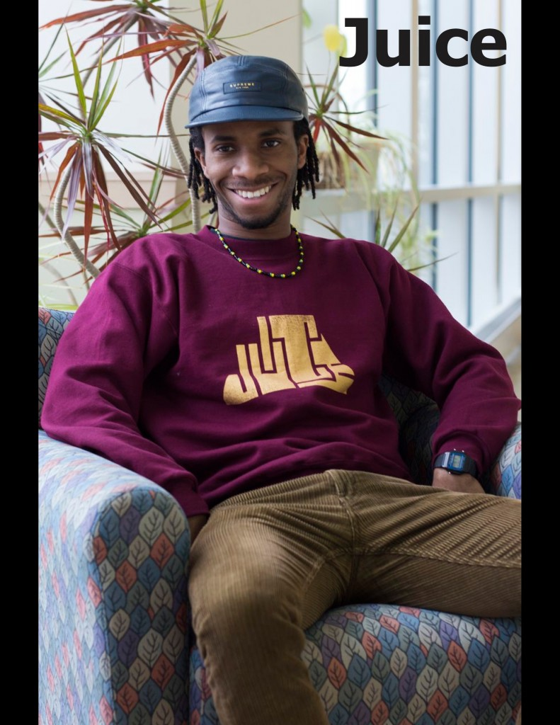

**Jonathan Allotey:**[**College Item**](http://launch.spaces.wooster.edu/jonathan-allotey-college-item/)



Bailey Connor: [Carica Road](http://launch.spaces.wooster.edu/bailey-connor-carica-road/" \o "Bailey Connor: Carica Road)



**Mentor**

* Mentor students
* Give presentations to students

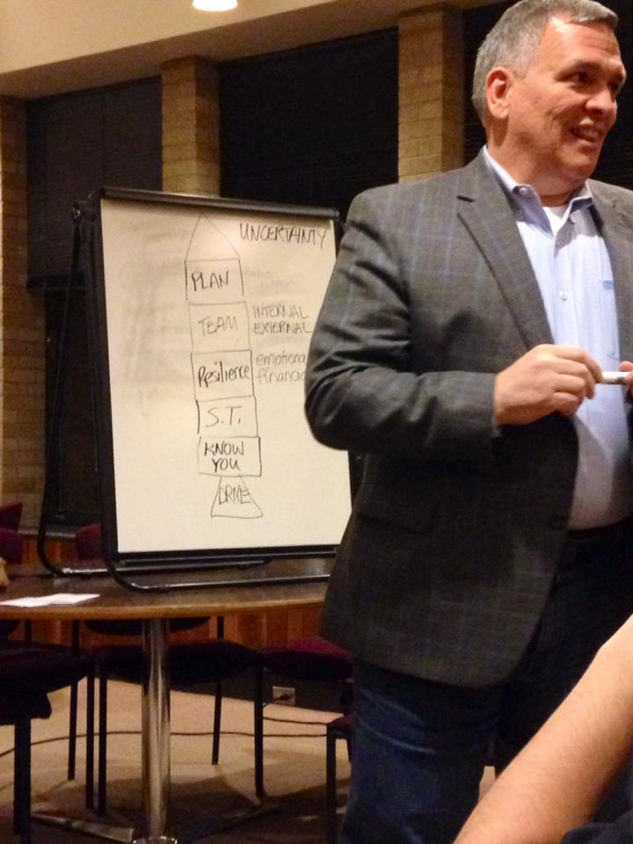

**Launch Club**

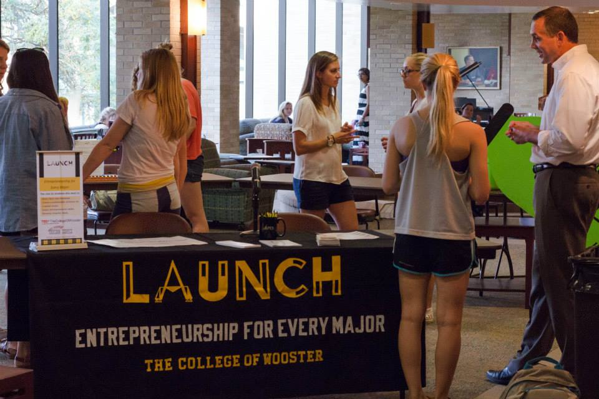

Join the student Entrepreneurship Club known as [Launch](http://launch.spaces.wooster.edu/). Launch brings entrepreneurs to campus, helps students develop their own start-up ideas, organizes company tours, and manages TEDxWooster.

* **About**

Launch is the student entrepreneurship club for every major.  The purpose of the club is to support students who want to:

* Start new ventures
* Create solutions to problems
* Connect to regional resources
* Network both on and off campus
* **Club Initiatives**

Launch is involved in many initiatives. Including:

* Host TEDxWooster
* Host the Idea/Business Model Competition
* Bring entrepreneurs to campus
* Organize visits to regional businesses
* Partner with the city on a revolving loan fund
* Collaborate with students on the creation of new businesses
* **Launch Club website**

<http://launch.spaces.wooster.edu/>

**Entrepreneurial Media**

* Videos

1. **Life of an entrepreneur**

* What is an entrepreneur? Definition, characteristics and examples

<http://education-portal.com/academy/lesson/what-is-an-entrepreneur-definition-characteristics-examples.html#lesson>

* Life of a young entrepreneurship

<https://www.youtube.com/watch?v=OjYceP2Fup4>

* 10 mistakes made by entrepreneurs

<https://www.youtube.com/watch?v=gtHZUr3mdlY>

* Discover the entrepreneurial mindset

<https://www.youtube.com/watch?v=N8eC5qR9_Wo>

* The most successful small business in the world

<https://www.youtube.com/watch?v=YtkV6bZB8ZY>

1. **Start a Business**

* 8 things you need to know before starting a business

<https://www.youtube.com/watch?v=2OH3ltrKbko>

* How to start a business: Ideas for starting a business

<https://www.youtube.com/watch?v=M4U8wpOpLuk>

* How to create a relevant small business

<https://www.youtube.com/watch?v=IEMQxBYEGRM>

* How to start and grow a business

<https://www.youtube.com/watch?v=rOxx8IV92C8>

* Building your team

<https://www.youtube.com/watch?v=SK27TqxV4ko>

* How to start a college business with the right mind set <https://www.youtube.com/watch?v=fpySHO566xA>
* How to get funding when starting a college student business <https://www.youtube.com/watch?v=oe8PakQk8Mg>
* BEST small business ideas for college students

<https://www.youtube.com/watch?v=Wcf6qp96rqY>

* What is branding

<https://www.youtube.com/watch?v=QPkWEN89WQU>

* Branding your small business

<https://www.youtube.com/watch?v=LMzYNC9LQ7U>

1. **Creating a product**

* Making something people love

<https://www.youtube.com/watch?v=KKYkmYuk5l8>

* Product development stages

<https://www.youtube.com/watch?v=KWy4UgbzCBU>

* Turning user insight into product

<https://www.youtube.com/watch?v=68OpSJuM3HQ>

* 5 Product Research Tools

<https://www.youtube.com/watch?v=zKYMFiXQwAo>

1. **How to market a product or business**

* Finding Product Market Fit

<https://www.youtube.com/watch?v=c-ruOFVG078>

* Growing your business with you tube

<https://www.youtube.com/watch?v=f_8cLll2Dqc>

* LinkedIn marketing

<https://www.youtube.com/watch?v=FCKtfcAGUTE>

* How to market your small business

<https://www.youtube.com/watch?v=lYvLUVqEp-c>

* Five low cost marketing strategies for small businesses

<https://www.youtube.com/watch?v=bMIxDH_s20I>

* Internet marketing strategy (step by step)

<https://www.youtube.com/watch?v=h_-a-w_lYjA>

* How to sell your product online (before you create it) <https://www.youtube.com/watch?v=rXlB5WUEWWM>
* 7 steps to product launch marketing success

<https://www.youtube.com/watch?v=R3tnZVCaDIg>

* Launching a new product

<https://www.youtube.com/watch?v=VVMAswJf1dc>

* 9 pricing rules for entrepreneurs

<https://www.youtube.com/watch?v=redLOAIkEvI>

* How to market your product

<https://www.youtube.com/watch?v=BCWoMxFUy4w>

1. **Student Stories/ businesses**

* From student to startup entrepreneur

<https://www.youtube.com/watch?v=K-5fHO95A2c>

* College student on how to start your own business with Verve energy drink <https://www.youtube.com/watch?v=LHg-GH13uA0>
* Dogs and dreams (student dogwalking business)

<https://www.youtube.com/watch?v=QwdTXitaEFs>

* Student Selling Jewerly

<http://www.smarta.com/advice/starting-up/student/sophie-bhamj-precious-jewellery/>

* Photo gallery

<https://www.dropbox.com/sh/8qu1jmomc6rykha/AAAxvTGNZLsYoLNLTyfSjABca?n=304998567#/>

* Podcasts

**Struggling entrepreneur podcast**

(deals with the issues, challenges and problems of the individual who wants to be an entrepreneur, but who encounters a somewhat difficult path and appears to be struggling)

<https://itunes.apple.com/us/podcast/id263476128>

**Venturevoice podcast**

(explores how entrepreneurs build their businesses and live their lives.)

<http://www.venturevoice.com/>

**E-corner** **podcast**

(deals with entrepreneurship education)

<http://ecorner.stanford.edu/podcasts.html>

**Entrepreneur.com podcast**

(deals with every aspect of your business)

<http://www.entrepreneur.com/podcast/>

**From Scratch podcast**

(This is a radio show about Entrepreneurship Life)

<https://itunes.apple.com/us/podcast/from-scratch/id187687651?mt=2>

**The smart passive income podcast**

(This is a business podcast that provides tips on how to improve your business)

<https://itunes.apple.com/us/podcast/smart-passive-income-podcast/id383084001>

**Daily boost**

(Provides motivation for improving your business, your life etc)

<https://itunes.apple.com/us/podcast/id207251905>

**WSJ small business bulletin**

(Insights for starting and running a small business)

<http://online.wsj.com/public/page/podcast.html>

**Ducttapemarketing podcast**

(Marketing advise)

<http://www.ducttapemarketing.com/blog/category/podcast/>

**Help my business sucks**

(small Business marketing tips)

<http://helpmybusiness.com/archive/>

**Twist**

(This week in startups) [gives you an insider's look at what's happening in the tech industry]

<http://thisweekinstartups.com/>

**Small Business Trends Radio**

(Small business trends)

<http://www.smbtrendwire.com/index-of-conversations/>

**Think entrepreneurship**

(interviews with entrepreneurs, tips)

<https://itunes.apple.com/us/podcast/think-entrepreneurship-interviews/id636844778?mt=2>

**Idea/Business model competition**

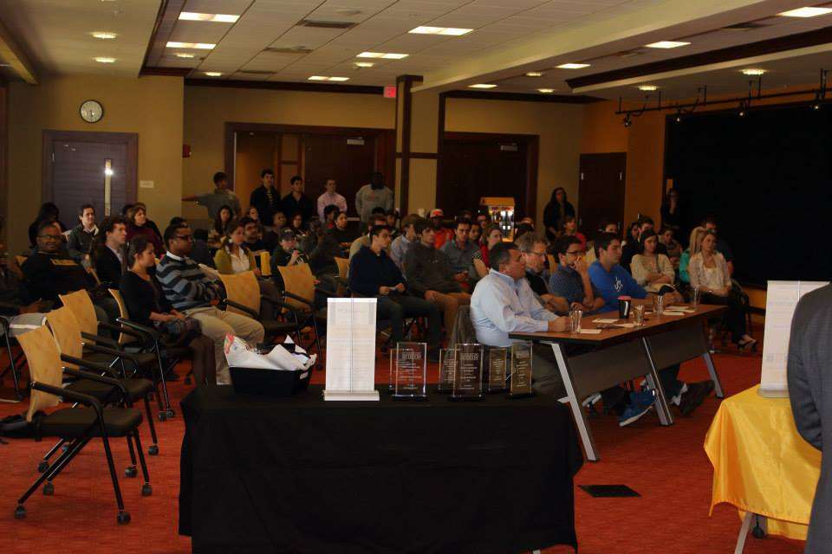

Have an idea for a new product or service? Present it in the Business Model Competition.  Students compete for prizes before a panel of entrepreneurs, professors and community leaders.

All students are invited to compete in the Wooster Business Idea/Model Competition. Please complete the [entry forms](http://www.wooster.edu/_media/files/academics/apex/entrepreneurship/competition/entry-form.pdf) (.pdf) to compete.

Event Date: October 18 at 6:00 p.m.

Deadline to Submit: October 4.

## Categories

New Business Concept – Any type of new business that sells either a product or service.

Student Business Concept – A business that a student could start on campus while still enrolled in college.  It does not necessarily have to be a business for other students, it merely needs to be one you can create while you are still a student.

Social Entrepreneurship Concept – A business that will generate profit that will be used to address a social or civic issue.

See the [business model tri-fold](http://www.wooster.edu/_media/files/academics/apex/entrepreneurship/competition/business-model.pdf) (.pdf).

## Process

* Submit an application by October 4 to the Director of Entrepreneurship in APEX 35.
* Selected applicants attend preparation training the following week to prepare a 5-minute presentation.  You can either meet with Launch, the student entrepreneurship club, on Oct. 10 at 6:30 p.m. in the Tartan Room, or with the Director of Entrepreneurship in APEX 35 on Oct. 10 or 11.
* All presentations must be in the form of a business model.
* Create a power point presentation that shows your business model.
* Remember – you only have 5-minutes and time will be strict.
* Present your concept before a live audience and panel of judges on October 18 at 6:00 p.m.
* Presentations will be in the Governance room on the ground floor of the Scott Center.  Plan to arrive by 5:45 p.m.
* A panel of judges will pick two winners from each category.
* First place in each category wins $1,000
* Runner-up in each category wins $750
* All winners are obligated to begin implementing their idea with the help of the Center for Entrepreneurship and Launch.

Funding for the Business Idea/Model Competition is provided through a generous grant from the Burton D. Morgan Foundation.

**TEDx Wooster**

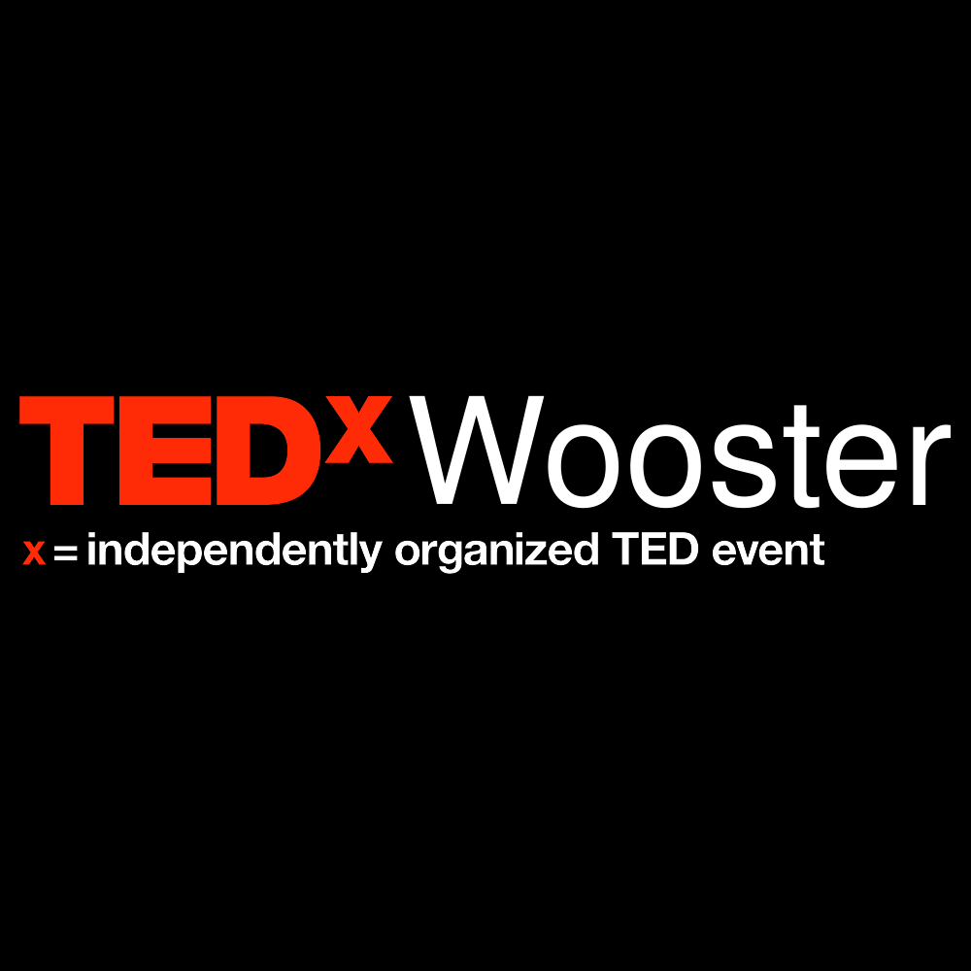

* **PUSH**

<https://www.ted.com/tedx/events/13181>

* **DOUBLE-TAKE**

<https://www.ted.com/tedx/events/9835>

* **Tedx Wooster Videos**

<https://www.youtube.com/user/TEDxTalks/search?query=tedxwooster>